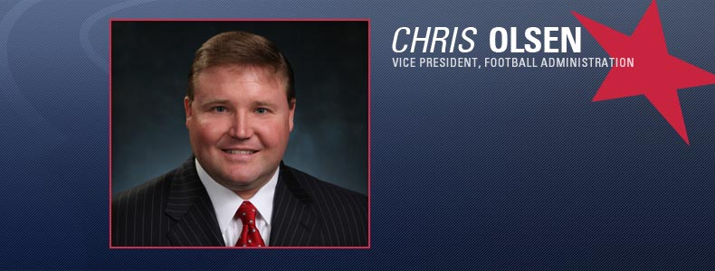
Chris Olsen
Vice President of Football Administration
Chris Olsen is in his eighth season with the Texans and fifth as the team’s vice president of football administration. Olsen’s primary responsibility with the Texans is to work closely with General Manager and Executive Vice President Rick Smith on negotiating player contracts and managing the salary cap.
Chris Olsen is in his eighth season with the Texans and fifth as the team’s vice president of football administration. Olsen’s primary responsibility with the Texans is to work closely with General Manager and Executive Vice President Rick Smith on negotiating player contracts and managing the salary cap.
Prior to joining the Texans’ staff, Olsen spent 13 years working at the National Football League office in New York. Olsen served as the manager of labor operations with the NFL Management Council from 1999-2006. He was responsible for reviewing and analyzing player contracts to ensure teams were in compliance with the Collective Bargaining Agreement (CBA) and salary cap, and also provided assistance to club executives pertaining to player-related areas of the CBA. He also served as a League liaison to the NFL Players Association regarding player contract matters, served as a national game representative, as well as an instant replay communicator.
Olsen began his tenure with the NFL in 1994 as an analyst in the player personnel department. He was promoted to coordinator in 1998 and became responsible for all facets of the player petition process on special eligibility for the NFL Draft (underclassman prospects), including coordinating player evaluations for the College Advisory Committee. He produced annual reports for the Competition Committee and reviewed player contracts to ensure their compliance with the NFL’s Constitution and By-Laws.
Olsen began working in professional sports during his senior year in college with the Springfield Indians Hockey Club of the AHL in 1989-90, where he served as a public relations/marketing intern. After spending a brief time working for Ark-Asset Management Company, a financial services firm in New York City, he continued his sports career in 1992 while in graduate school by serving as a public relations/marketing intern for the Hartford Whalers of the NHL. Prior to joining the NFL, he worked for the New Jersey State Golf Association.
Olsen is a native of Little Silver, N.J. He earned his degree in business administration from Western New England College in 1990 and earned a master’s degree in sports management from Springfield College in 1997. Olsen and his wife, Kim, reside in Houston.

